2014 VASE registration instructions
As always the system is wiped clean each year, so you do have to reestablish your profile, however your profile now comes from your TAEA membership. You must be a current registered TAEA member to enter your vase entries into the system. In the past you have been able register your students and take care of your membership later that can no longer be the case. In the past you have filled out the profile and waited for me to activate you registration, you no longer have to wait. Once your membership is currents and you have verified your information is correct and current, and you have set up your own password, you can start entering students immediately.

Are you ready? Here we go….
- From the TAEA web site, click on the VASE link.

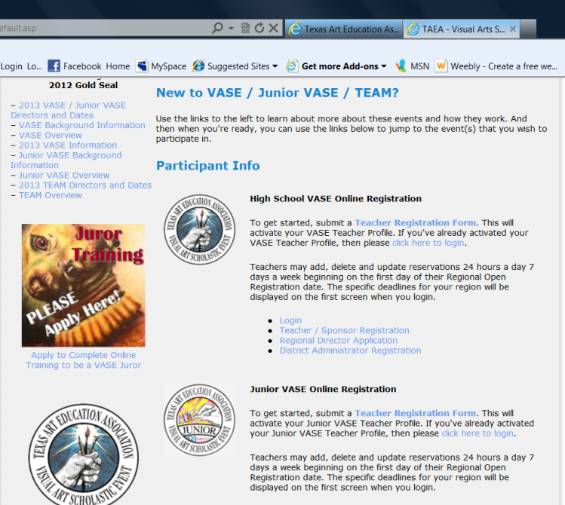
- That will take you to this page, scroll down to find the participant information, click on the link for Teacher Sponsor Registration

- Next select login

- Select click here to join online, renew, or establish your login credentials
- On this screen you will need to select whether or not you are a current TAEA member. Click according to your answer.
- If you are not a current member it will direct you to the payment/registration page. As I said above you will NOT be able to enter your student in the system until you are a current TAEA member.
- If you are a current member, you will be directed to the next pages to set up your login credentials

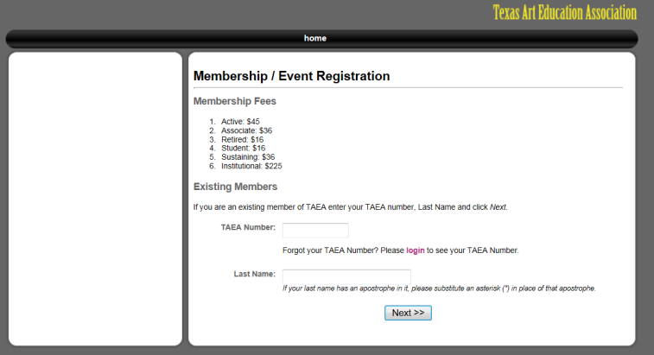

- On this screen enter your TAEA number and your last name, click Next

- If you are a current member, this screen should pop up with your information in it.
- Make sure everything is accurate and current.
- MOST IMPORTANT!!! You need to establish your own personal Password!!!!
Once you have done this, click next. You should be done

- NOW you will be able to go to the VASE site and actually LOGIN with your email address and your personal password.
Just a note: I no longer have access to your password and will not be able to help you with that. TAEA will help you do that.

We are area 3

