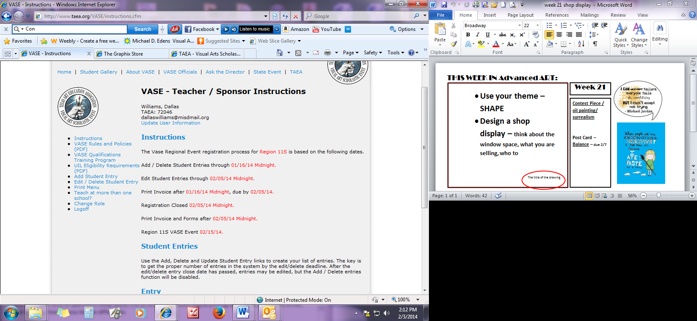

Here you will find the VASE Qualifications Program – new link added this year.

Go through it carefully; this will help you with any artwork classification questions, Originality, media, etc…

We should not have to DQ any pieces the day of the event for these kinds of offences. Please make sure you take the time to look this over.