To prepare 2D Art Work:

Backing – each light weight work must have a backing
This can be cardboard, poster board, or etc…

Art work – lightweight works need to be matted
You do not need to matt canvases, works painted
on ridged surfaces like wood.

Matt – each work must have a matt.
Either black or white.
Works (photos) can be mounted to matt board also

Cover sheet – each piece must have a cover sheet
Any paper will work, it should be larger than the art work but not larger than the matt. Tape them across the back of the top of the work and fold over. DO NOT tape then on top and bottom like present

2 D work that has objects sticking off the surface must have a box

To prepare 3D work:
Box - each piece needs a box that is shippable.
Packing Material - You put a lot of work into
the piece. Pack it with lots of packing material to protect it

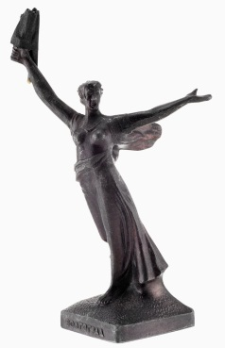

Paper work attached to work -
- a piece of stiff board 4 ¼ x 5 ½.
- A copy of the student intent and art work identification form
Folded into quarters and glued to the board.
Hole punch and tie to the work

Paper work attached to outside of box –
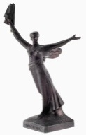
- A photograph of the art work 8 ½ x 11 preferred (understand some boxes are smaller)
- A copy of the student intent and art work identification form

